GEE-72810 | Unit Testing
Description:
As the lead for data management, I want the External Centralized Form Processor CloudPage code to be refactored and cleaned up per a previous Spike (GEE-35446), so that we can improve processing performance and development process.

Additionally, the data management team reported 404 Error experienced by Anteriad while posting leads to the External Centralize Form Processor: INC4979312

Contact Point Email record already existed in Salesforce for the submitted email address. During processing, the Centralized Form Processor (CFP) attempted to perform the standard Contact Point Email lookup to identify an existing Contact/Lead and retrieve associated consent information. However, at the time of processing, the required Salesforce data was not returned to CFP. As a result, no Salesforce ID was obtained, and CFP followed the new Lead creation path. Salesforce subsequently rejected the Lead creation request because the email address already existed in Contact Point Email.

External CFP will be enhanced to handle scenarios where an existing Contact Point Email record is not returned during the lookup process. Additional checks will be put in place prior to attempting to create a new lead.
Acceptance Criteria:
SCENARIO 1: Remove Inquiry Type logic
GIVEN Inquiry Type is not populated for submissions processed by the External Centralized Form Processor (CFP)
WHEN the External CFP Page code is cleaned up
THEN the Inquiry Type checks and associated conditional branches will be removed from the External CloudPage
AND no Inquiry Type-dependent code will remain

SCENARIO 2: Remove Contact Us journey logic
GIVEN the Contact Us journey logic is not applicable to submissions processed by the External CFP
WHEN the journey-processing code is cleaned up
THEN the Contact Us journey conditions and execution logic will be removed from the External CloudPage
AND no Contact Us journey-specific code will remain

SCENARIO 3: Consolidate lead creation and update logic
GIVEN lead creation and update logic is duplicated based on whether Inquiry Type is null or not null
WHEN the External CFP code is refactored
THEN the duplicated logic will be consolidated into a single lead creation and update flow
AND the consolidated flow will create a new lead when no matching Salesforce record is found
AND the consolidated flow will update the applicable lead or contact when a matching Salesforce record based on existing logic //Certain attributes are not updated, this should remain the same as today

SCENARIO 4: Error handling of existing Contact Point Email not returned by the initial lookup
GIVEN a form submission contains an email address associated with an existing Contact Point Email record
WHEN the External Centralized Form Processor evaluates the submission
THEN the External CFP logic will perform an additional check for an existing matching Contact Point Email before classifying the submission as a new lead
AND the CFP will use the Salesforce Lead or Contact associated with the matching Contact Point Email for continued processing
AND no duplicate-email validation error will be generated from an attempted Lead creation

SCENARIO 5: Remove redundant ContactPointEmail lookups
GIVEN the External CFP performs repeated ContactPointEmail lookups to retrieve the Salesforce ID
WHEN the data-retrieval code is optimized
THEN redundant ContactPointEmail lookups will be removed
AND the value returned by the required lookup will be stored and reused by subsequent processing steps

SCENARIO 6: Expand error-log details
GIVEN the current error logging does not capture all relevant submitted values
WHEN an error is recorded by the External CFP
THEN Centralized_Form_Processor_DE_Error_Log will be populated with the relevant submitted field values available at the point of failure
AND the captured values will provide additional context for troubleshooting the failed submission
Business Unit: UAT

Set the required field values in the payload & send the request using POST request in Postman.
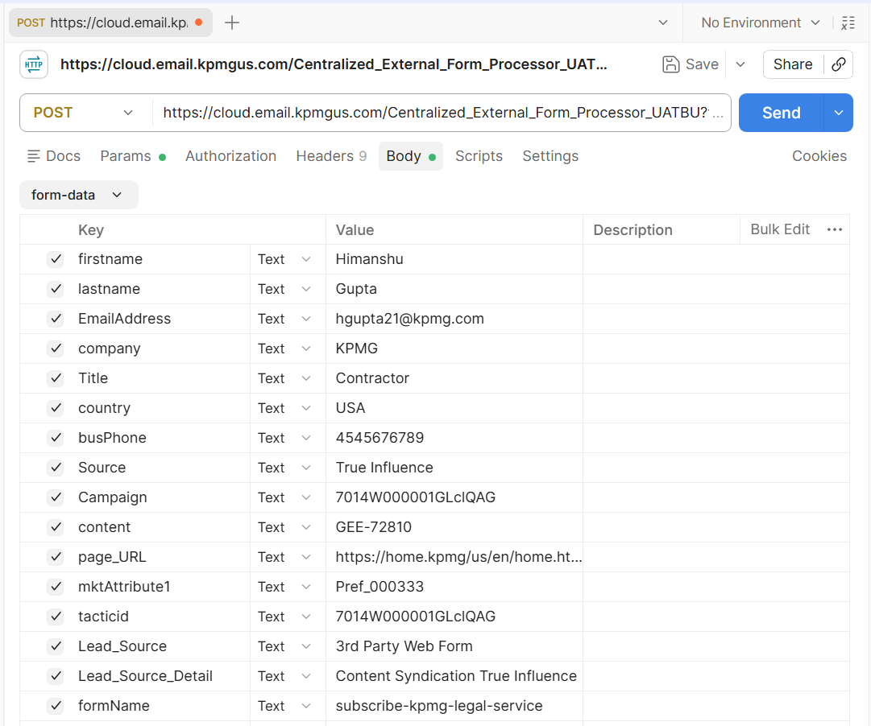
The request was submitted successfully, and a 200 OK response was received from the API.
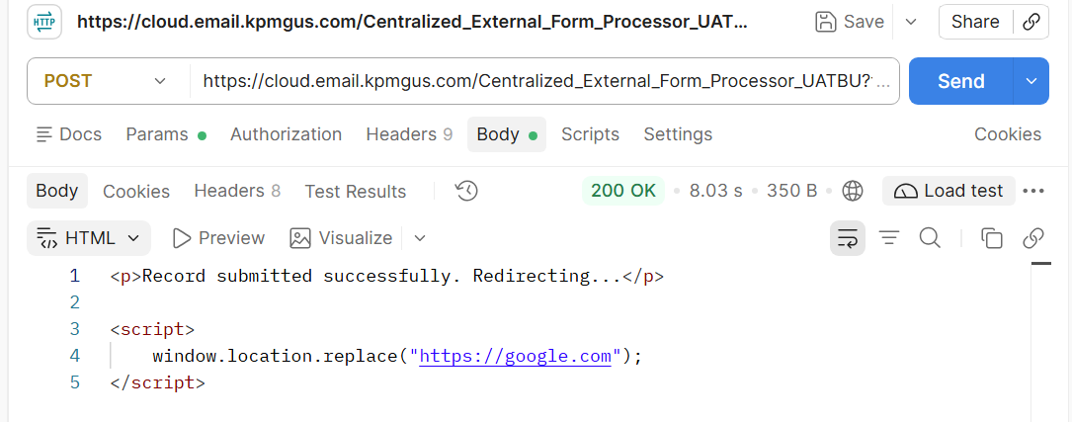
After an external form submission, the record is inserted into the Centralized_Form_Processor_DE, and the Sales Cloud consent status is updated to Opt In.
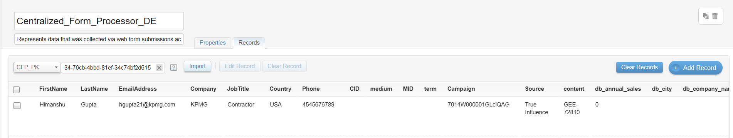
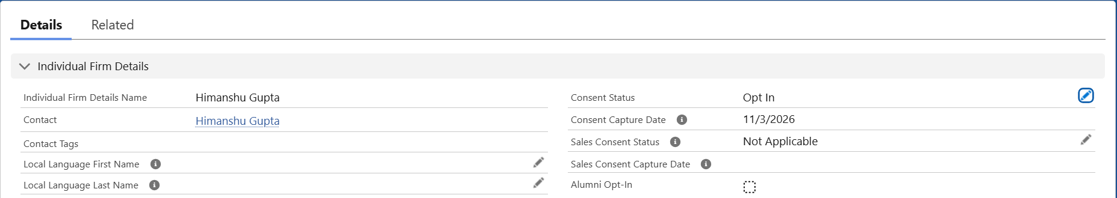
The record is processed successfully and inserted into the corresponding preference-related Data Extensions based on the submitted preferences.
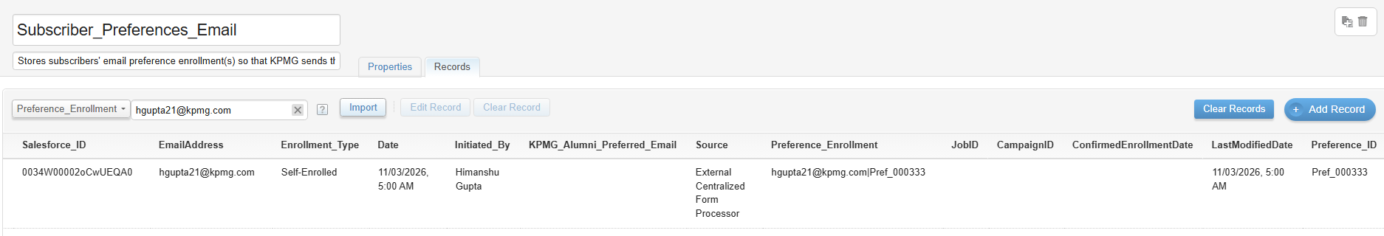
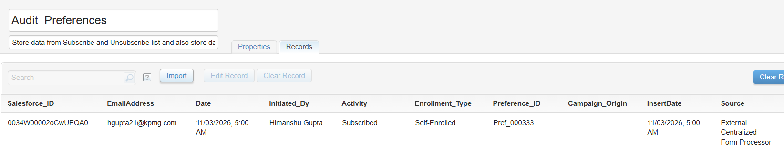
In addition to the preferences Data extension, the record is processed successfully and inserted into the corresponding CFP journey entry data extension and Dynamic_Journey_Form_Processor_DE.
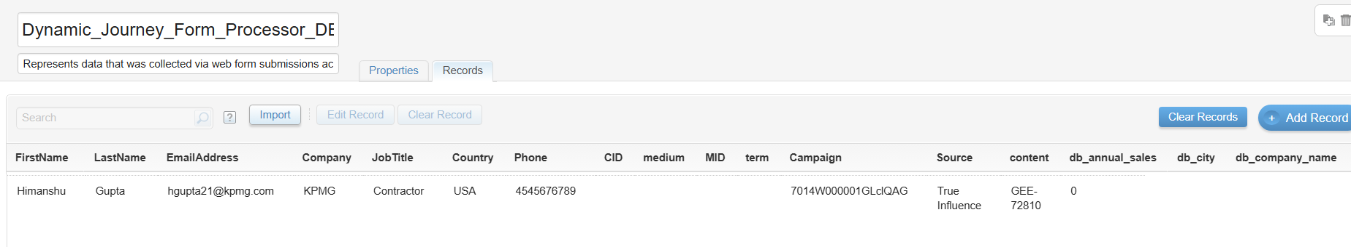

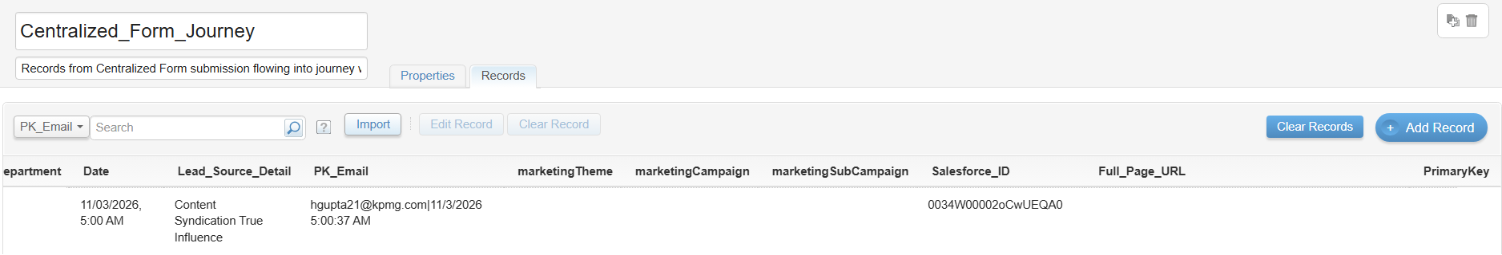
The record has been successfully injected into the Centralized Form Journey.
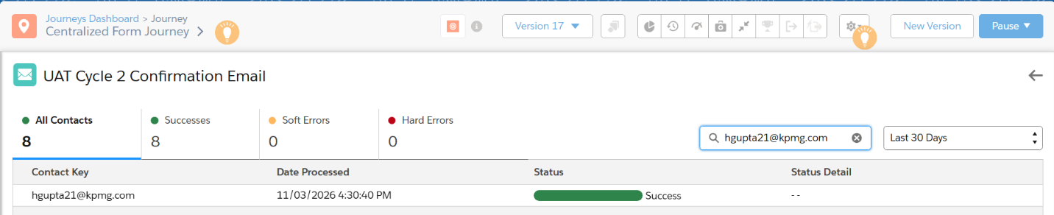
***************************************** End of the Document ***********************************************

